**Practical No.4**

* **Study of Event Model and Callback.**
* CODE for EventEmitter :-

var events=require('events');

var eventemitter=new events.EventEmitter();

var Handler=function connected()

{

console.log("Connection Establish");

eventemitter.emit('download');

}

eventemitter.on('download',function()

{

console.log("file download");

});

eventemitter.on('connection',Handler);

eventemitter.emit('connection')

console.log("program terminated...");

* OUTPUT :-

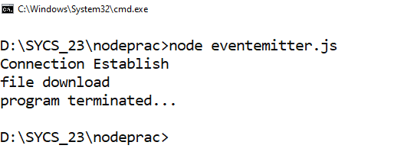

* **Callback :-**
* Create simple.txt file :-

Hello..

My name is Krishna..

* CODE for callback.js file :-

var fs=require('fs')

var fd=fs.readFileSync("simple.txt");

console.log(fd.toString());

console.log("Program End..");

fs.readFile('simple.txt',function(err,data)

{

if (err) return console.error(err);

console.log(fd.toString());

});

console.log("Program Ended...");

* OUTPUT :-

